­

Name ______________ Period ___ Rack ___ Partner ____________

8.2.3.4 – PT – Configuring Stateless and Stateful DHCPv6

Topology Instructor Signoff ______________

­­

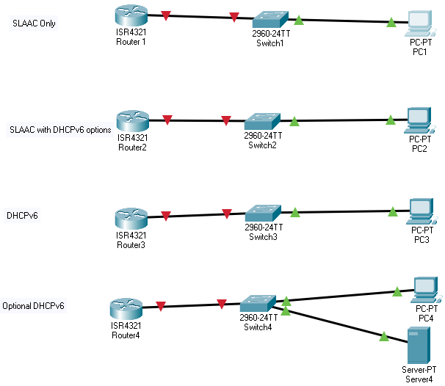

Challenge DHCPv6

1. Addressing Table

|  |  |  |  |  |
| --- | --- | --- | --- | --- |
| Device | Interface | IPv6 Address | Prefix Length | Default Gateway |
| R1 | G0/0/0 | 2001:DB8:ACAD:A::1 | 64 | N/A |
| PC1 | Fa0/0 | Assigned by SLAAC | 64 | Assigned by SLAAC |
| R2 | G0/0/0 | 2001:DB8:ACAD:B::1 | 64 | N/A |
| PC2 | NIC | Assigned by SLAAC and DHCPv6 | 64 | Assigned by R1 Server2 |
| R3 | G0/0/0 | 2001:DB8:ACAD:C::1 | 64 | N/A |
| PC3 | NIC | Assigned by DHCPv6 | 64 | Assigned by Server 3 |
|  |  |  |  |  |

1. Objectives

Part 1: Configure the Network for SLAAC

Part 2: Configure the Network for Stateless DHCPv6

Part 3: Configure the Network for Stateful DHCPv6

Part 4: Configure a DHCPv6 server through a GUI

1. Background / Scenario

The dynamic assignment of IPv6 global unicast addresses can be configured in three ways:

* Stateless Address Autoconfiguration (SLAAC) only
* Stateless Dynamic Host Configuration Protocol for IPv6 (DHCPv6)
* Stateful DHCPv6

With SLAAC (pronounced slack), a DHCPv6 server is not needed for hosts to acquire IPv6 addresses. It can be used to receive additional information that the host needs, such as the domain name and the domain name server (DNS) address. When SLAAC is used to assign the IPv6 host addresses and DHCPv6 is used to assign other network parameters, it is called Stateless DHCPv6.

With Stateful DHCPv6, the DHCP server assigns all information, including the host IPv6 address.

Determination of how hosts obtain their dynamic IPv6 addressing information is dependent on flag settings contained within the router advertisement (RA) messages.

1. Configure Basic Device Settings
   1. Configure R1, R2, and R3.
      1. Disable DNS lookup.
      2. Configure the device name.
      3. Encrypt plain text passwords.
      4. Create a MOTD banner warning users that unauthorized access is prohibited.
      5. Assign **class** as the encrypted privileged EXEC mode password.
      6. Assign **cisco** as the console and vty password and enable login.
      7. Set console logging to synchronous mode.
   2. Configure S1, S2 and S3.
      1. Configure ports fa 0/1 - 3 with the command S1(config-if-range)#spanning-tree portfast
2. Configure the Network for SLAAC
   1. Configure R1.
      1. Enable IPv6 unicast routing.
      2. Assign the IPv6 unicast address to interface G0/0/0 according to the Addressing Table.
      3. Assign FE80::1 as the IPv6 link-local address for interface G0/0/0.
      4. Activate interface G0/0/0.
   2. Verify that R1 is part of the all-router multicast group.

Use the **show ipv6 interface g0/0/0** command to verify that G0/0/0 is part of the All-router multicast group (FF02::2). RA messages are not sent out G0/0/0 without that group assignment.

* 1. Verify that SLAAC provided IPv6 address information on PC-A.
     1. From a command prompt on PC-1, issue the **ipconfig /all** command. Verify that PC-1 is showing an IPv6 address with the 2001:db8:acad:a::/64 prefix. The Default Gateway should have the FE80::1 address.

1. Configure the Network for Stateless DHCPv6
   1. Configure an IPv6 DHCP server on R2.
      1. Create an IPv6 DHCP pool.

R2(config)# **ipv6 dhcp pool IPV6POOL-B**

* + 1. Assign a domain name to the pool.

R2(config-dhcpv6)# **domain-name ccna-statelessDHCPv6.com**

* + 1. Assign a DNS server address.

R2(config-dhcpv6)# **dns-server 2001:db8:acad:b::abcd**

R2(config-dhcpv6)# **exit**

* + 1. Assign the DHCPv6 pool to the interface.

R2(config)# **interface g0/0/0**

R2(config-if)# **ipv6 dhcp server IPV6POOL-B**

* + 1. Set the DHCPv6 network discovery (ND) **other-config-flag**.

R2(config-if)# **ipv6 nd other-config-flag**

R2(config-if)# **end**

* 1. Verify DHCPv6 settings on interface G0/0/0 on R2.

Use the **show ipv6 interface g0/0/0** command to verify that the interface is now part of the IPv6 multicast all-DHCPv6-servers group (FF02::1:2). The last line of the output from this **show** command verifies that the other-config-flag has been set.

* 1. View network changes to PC-B.

Use the **ipconfig /all** command to review the network changes. Notice that additional information, including the domain name and DNS server information, has been retrieved from the DHCPv6 server. However, the IPv6 global unicast and link-local addresses were obtained previously from SLAAC.

* 1. Verify that PC-B did not obtain its IPv6 address from a DHCPv6 server.

Use the **show ipv6 dhcp binding** and **show ipv6 dhcp pool** commands to verify that PC-B did not obtain an IPv6 address from the DHCPv6 pool.

R2# **show ipv6 dhcp binding**

R2# **show ipv6 dhcp pool**

**You should NOT see any output. Why?**

1. Configure the Network for Stateful DHCPv6
   1. Set the DHCPv6 pool on R3.
      1. Create an IPv6 DHCP pool.

R3(config)# ipv6 dhcp pool IPV6POOL-C

* + 1. Assign a network address to the pool.

R3(config-dhcpv6)# **address prefix 2001:db8:acad:c::/64**

* + 1. Assign a domain name to the pool.

R3(config-dhcpv6)# **domain-name ccna-statefulDHCPv6.com**

* + 1. Assign a DNS server address.

R3(config-dhcpv6)# **dns-server 2001:db8:acad:c::abcd**

R3(config-dhcpv6)# **exit**

* + 1. Assign the DHCPv6 pool to the interface.

R3(config)# **interface g0/0/0**

R3(config-if)# **ipv6 dhcp server IPV6POOL-**C

* + 1. Set the DHCPv6 network discovery (ND) **managed-config-flag**.

R3(config-if)# **ipv6 nd managed-config-flag**

R3(config-if)# **end**

* + 1. Verify DHCPv6 pool settings.

R3# **show ipv6 dhcp pool**

* + 1. Enter debug mode to verify the Stateful DHCPv6 address assignment.

R3# **debug ipv6 dhcp detail**

IPv6 DHCP debugging is on (detailed)

* 1. Verify Stateful DHCPv6 settings on R3.
     1. Issue the **show ipv6 interface g0/0/0** command to verify that the interface is in Stateful DHCPv6 mode.

R3# **show ipv6 interface g0/0/0**

* + 1. In a command prompt on PC-C, type **ipconfig /release6** to release the currently assigned IPv6 address. Then type **ipconfig /renew6** to request an IPv6 address from the DHCPv6 server.
    2. Issue the **show ipv6 dhcp pool** command to verify the number of active clients.

R3# **show ipv6 dhcp pool**

* + 1. Issue the **show ipv6 dhcp binding** command to verify that PC-C received its IPv6 unicast address from the DHCP pool. Compare the client address to the link-local IPv6 address on PC-A using the **ipconfig /all** command. Compare the address provided by the **show** command to the IPv6 address listed with the **ipconfig /all** command on PC-A.

R3# **show ipv6 dhcp binding**

* + 1. Issue the **undebug all** command on R3 to stop debugging DHCPv6.

**Note**: Typing **u all** is the shortest form of this command and is useful to know if you are trying to stop debug messages from continually scrolling down your terminal session screen. If multiple debugs are in process, the **undebug all** command stops all of them.

R3# **undebug all**

All possible debugging has been turned off

* + 1. Review the debug messages that appeared on your R3 terminal screen.
       1. Examine the solicit message from PC-C requesting network information.
       2. Examine the reply message sent back to PC-C with the DHCP network information.

Step 5: Repeat the DHCPv6 lab but instead of using the Router3 as the DHCPv6 server use Server 4. Use the network 2001:db8:acad:c::

Here is a hint:

SEE NEXT PAGE

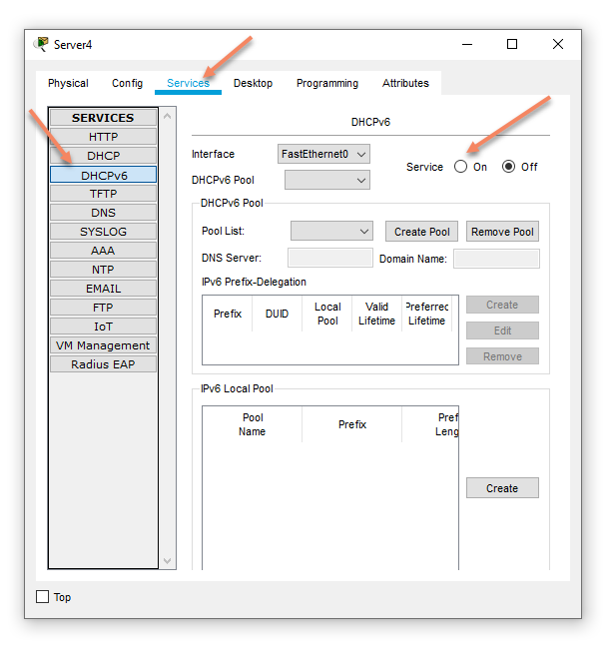

1. Reflection
   1. What IPv6 addressing method uses more memory resources on the router configured as a DHCPv6 server, Stateless DHCPv6 or Stateful DHCPv6? Why?

_______________________________________________________________________________________

_______________________________________________________________________________________

_______________________________________________________________________________________

* 1. Which type of dynamic IPv6 address assignment is recommended by Cisco, Stateless DHCPv6 or Stateful DHCPv6?

_______________________________________________________________________________________

_______________________________________________________________________________________